**Bug report 1. Title:** Button “Reset app state” doesn’t work.

**Type:** Bug

**Severity:** Critical

**Description:**

Button “Reset app state” at section “Menu” doesn’t work.

**Steps to reproduce:**

1. Log in: use username – standard_user; problem_user; performance_glitch_user

Passsword: secret_sauce

1. On main page click “Menu” button at the left side of page.
2. Click on it.
3. Click on “Reset app state.

**Actual result:** Button “Reset app state” doesn’t work

**Expected result:** Button “Reset app state” must be active because in this case the users can cancel all changes made on this page.

**Attachment:**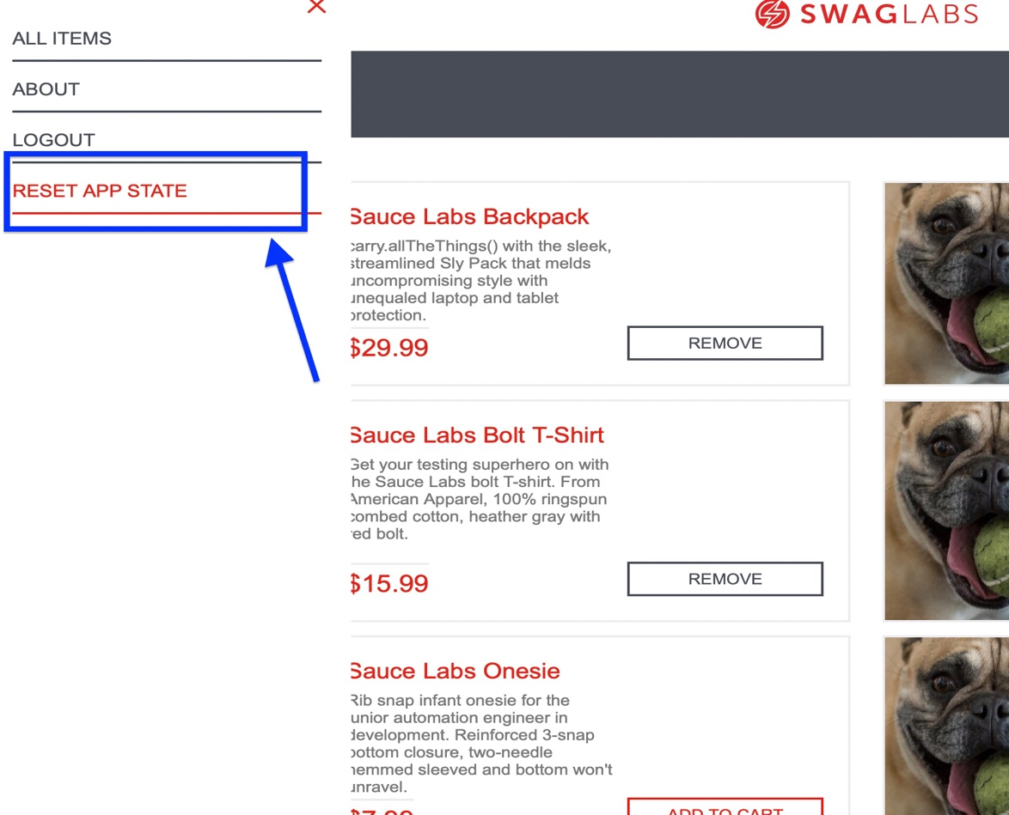

**Priority:** High

**Bug report 2. Title:** Logo “SwagLabs” doesn’t work as Home Page.

**Type:** Bug

**Severity:** Major

**Description:** Logo “SwagLabs” doesn’t work as Home Page.

**Steps to reproduce:**

1. Log in: user name – standard_user;

Password: secret_sauce

1. On main page click somewhere. For example, on the cart.
2. Click logo sign above the page.

**Actual result:** Sign “SwagLabs” doesn’t work as Home Page.

**Expected result:** Sign “SwagLabs” is clickable, and the user can come back to main page by clicking it.

**Attachment:**

**Priority:** Medium

**Bug report 3. Title:** The mouse cursor doesn’t change to a “hand” when you move it to the sign “Cart”.

**Type:** Trivial

**Severity:** Low

**Description:** At right side above of page moving the mouse cursor to sign “Cart” doesn’t change to “Hand”.

**Steps to reproduce:**

1. Log in: user name – standard_user; problem_user;

Password: secret_sauce

1. Move the mouse cursor to the sign “Cart”

**Actual result:** The mouse cursor doesn’t change into “Hand”

**Expected result:** Moving the mouse cursor to “Cart” it would change into the sign “Hand” and it’ll let you know that this button is clickable.

**Attachment:**

**Priority:** Low

**Test case 1**

**Title:** Product’s images at the section “Cart”.

**Precondition:** login: performance_glitch_user; password: secret_sauce

|  |  |
| --- | --- |
| **Test step** | **Expected result** |
| 1. On the main page there are 6 items with 6 squares for images near them. | Able to see the goods on images represented. |
| 1. Select a few goods by clicking on button “Add to cart”. | Able to click on the button “Add to cart” and it works properly. |
| 1. Go to the section “Cart” with already chosen goods. | Able to see the images represented near each selected good. |

**Test case 2**

**Title:** Goods sorting.

**Precondition:** login: problem_user; password: secret_sauce

|  |  |
| --- | --- |
| **Test step** | **Expected result** |
| 1. On the main page there are 6 goods. | Able to see goods sorted in sequence name (A-Z). |
| 1. Change the sorting method into name (Z-A) by click. | Sorting is changed properly in this sequence. |
| 1. Change the sorting method according to the price scale (Low to High) by click. | Successfully changed. |
| 1. Change sorting method into price scale (High to Low) by click. | Able to change. |

**Test case 3**

**Title:** Sign of “Total” sum below all chosen goods at the cart.

**Precondition:** login: standard_user; problem_user; password: secret_sauce

|  |  |
| --- | --- |
| **Test step** | **Expected result** |
| 1. On the main page there are 6 goods. | Able to see the images near each item. |
| 1. Near each item there is a command button “Add to cart”. | The button “Add to cart” works properly. |
| 1. Choose a few items by clicking on the button “Add to cart”. | The mouse cursor changes into “hand” moving to the button “Add to cart” and stays clickable. |
| 1. At section “Cart” there are chosen items. | Able to see items’ images and description near them. |
| 1. Scroll through below the chosen items. | Able to see the “Total” sign. |